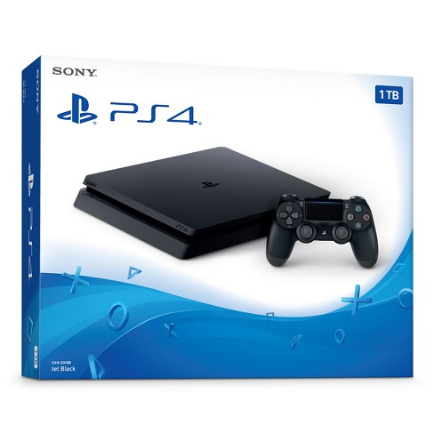

**PlayStation 4**

**Description:** The PlayStation 4 (PS4) is a home video game console developed by Sony Computer Entertainment. Announced as the successor to the PlayStation 3 in February 2013, it was launched on November 15, 2013, in North America, November 29, 2013 in Europe, South America and Australia, and on February 22, 2014 in Japan.

**System Specifications:**

* Single-chip custom processor
* CPU : x86-64 AMD “Jaguar”, 8 cores
* GPU : 1.84 TFLOPS, AMD Radeon™ based graphics engine
* GDDR5 8GB
* 500GB, 1TB

**Developed By:**

